# Chapter 8: Magnetism

**All Lectures Uploaded on YouTube:** [**https://tinyurl.com/fkm9-physics**](https://tinyurl.com/fkm9-physics)



## Magnetism

Magnetism finds its history to times back to the 600 BC, when the early loadstone, attracting the iron, was found in the region of Magnesia, from where it takes the name 'magnet'.

## 8.1 Domain Theory of Magnetism

As we know everything around us is made up of atoms, having a massive central body with positive charge known as nucleus and light particles with negative charge called electrons orbit around the nucleus.

According to the domain theory, atoms act like tiny magnets due to electron spin and orbital motion. In an unmagnetized material, magnetic domains (regions where atomic magnets align) are randomly oriented, canceling out magnetism. In a magnetized material, domains align in the same direction, producing a strong overall field.

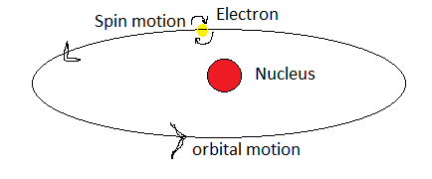

In some atoms electrons are so oriented that they may add up their magnetic field to make the atom with a net non-zero magnetic field, which makes the whole material as magnetic material.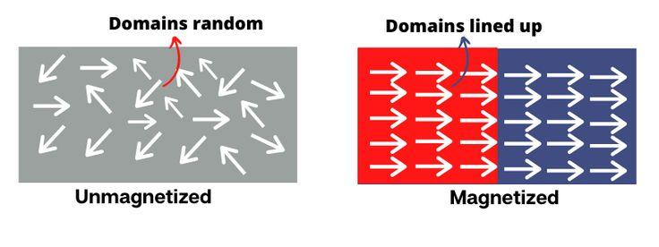

### 8.1.1 Force Between Magnetic Poles

Magnetic poles exert forces similar to electric charges. Like poles repel while unlike poles attract. The force depends on the strength of the poles and the distance between them. This is analogous to Coulomb’s law.

Similarly the materials which have magnetism are attracted by the opposite poles of a magnet. A magnetic material can also attract opposite poles of other magnetic materials.

## 8.2 Magnetic Field

**"The region or space around a magnet where it exerts a force on other magnetic poles is called a magnetic field".**

A magnetic field is the region around a magnet where magnetic forces act. It is represented by magnetic field lines that flow from the north to the south pole outside the magnet. The density of the lines indicates the strength of the field.

The **intensity of magnetic field (B)** at any point in the field can be **measured in the unit called tesla (T)**. Graphically the magnetic field is represented by the field lines.

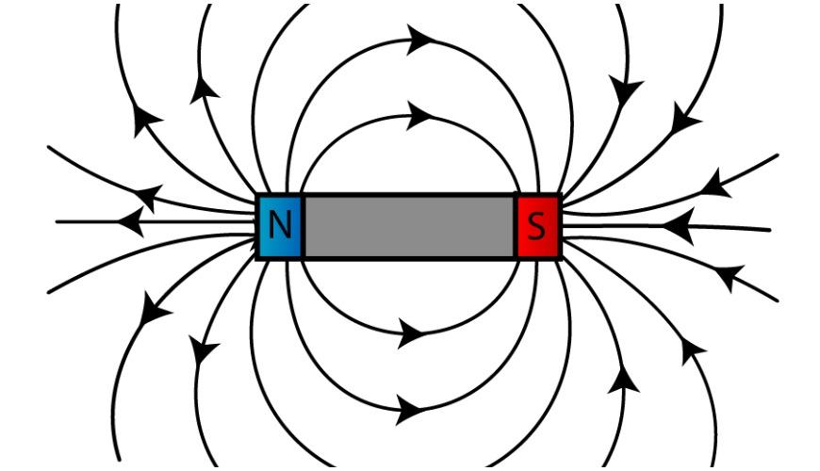

### 8.2.1 Magnetic Field of a Bar Magnet

A bar magnet is a rectangular part of a material which shows permanent magnetic properties. The magnetic field of a bar magnet can be found by placing the magnet on a plane sheet such that it has compass needles around it. 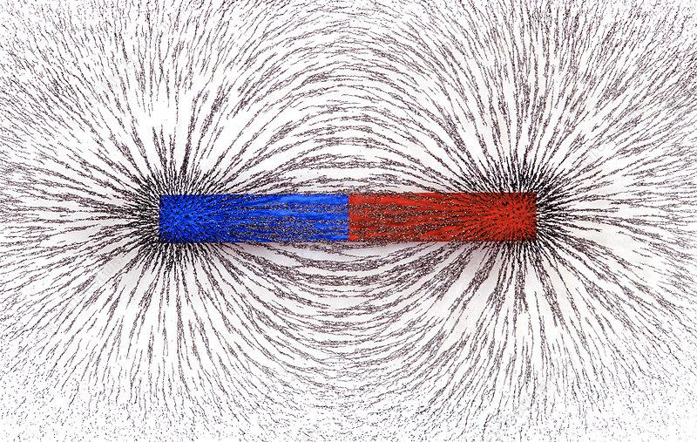

A bar magnet produces a dipole field. The field is strongest at the poles, where the lines are close together.

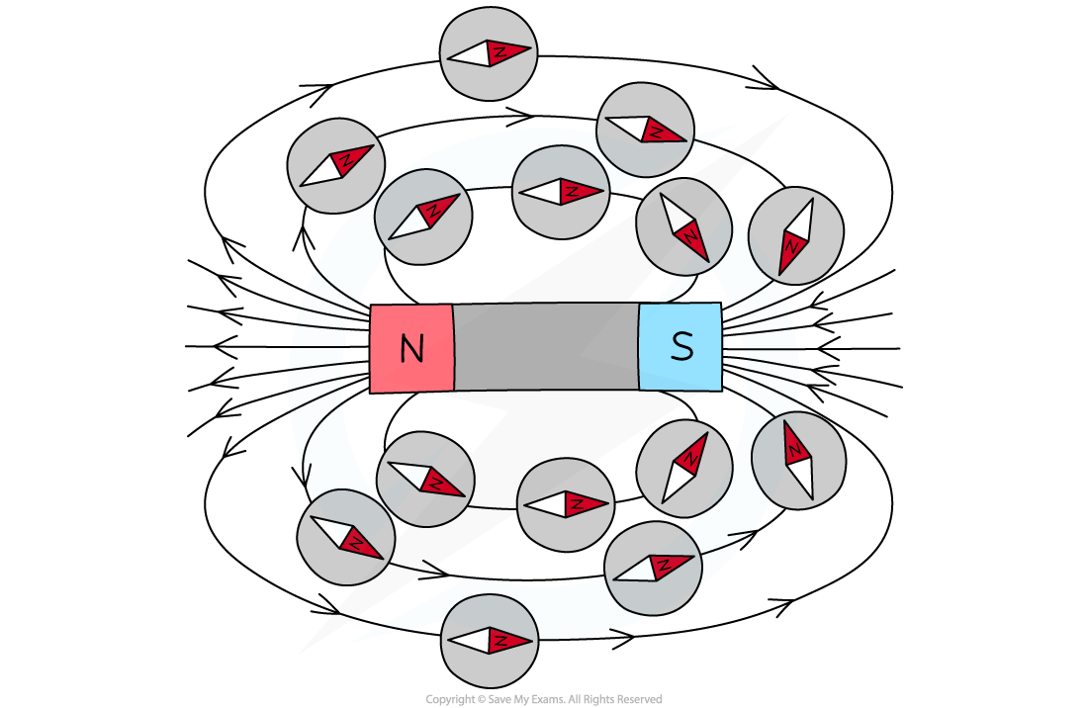

The field lines originate from N-pole and terminate at S-pole, while within the body of the magnet these lines travel from S-pole to N-pole.

### 8.2.2 Direction of Magnetic Field at a Point

The magnetic field is the map that we use to describe how the magnetic force is distributed in the space around a magnetic material or magnet and even within a magnetic material or magnet.

The direction of the field at a point is tangential to the field line there. It can be found using a compass needle, which aligns with the local field.

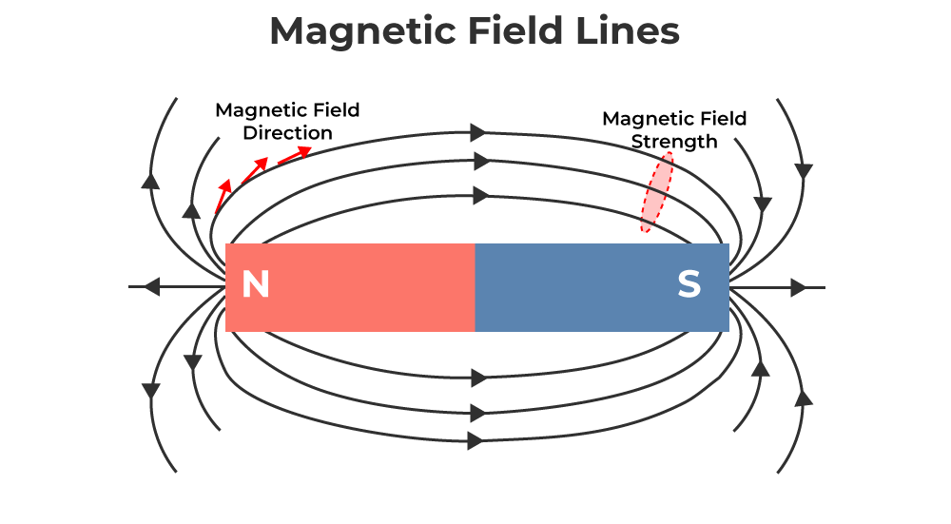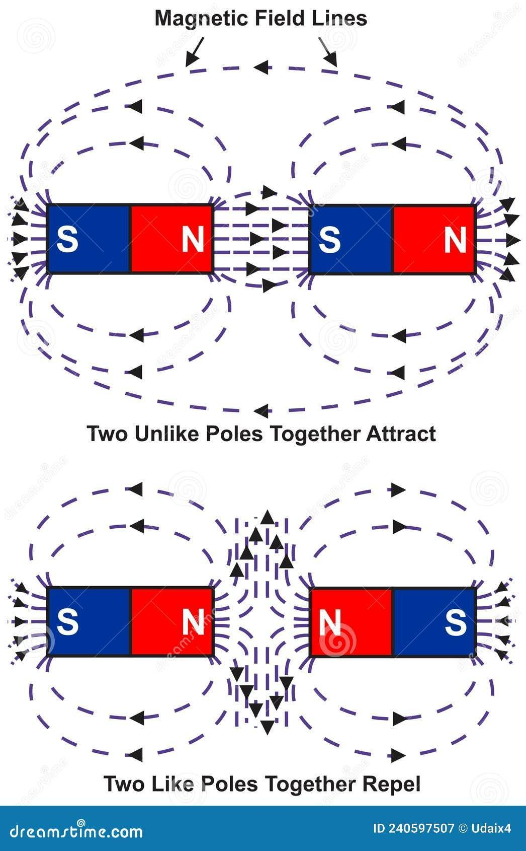

### 8.2.3 Relative Strength of Magnetic Field

The closeness of field lines shows relative strength. Lines close together mean strong fields, while lines far apart indicate weaker fields.

Hence magnetic field lines give the direction and the strength of the magnetic field. The relative strength of magnetic fields due to like poles and unlike poles is shown in the figure. By placing two N-poles close to each other we can decrease the field similarly by placing an N-pole near an S-pole we can make the magnetic field strengthen.

### 8.2.4 Magnetic Shielding

Magnetic shielding blocks external magnetic fields. Materials such as soft iron are used to protect sensitive instruments from interference.

There may be different orientations of the magnetic field by suitably adjusting the magnets. We can find a field free region called 'neutral zone' by placing two N-poles side by side, such that their field lines seem to repel each other by making a field free region, this phenomenon is called shielding of magnetic field.

## 8.3 Induced Magnetism

A material which is not a magnet in normal condition can be made a magnet with the help of some techniques and is called induced magnet and this phenomenon is called induced magnetism.

Induced magnetism occurs when a material becomes magnetized under an external magnetic field. The alignment of its domains causes it to act like a magnet.

### Stroking Method

The material is stroked repeatedly in one direction with a permanent magnet. This aligns the domains and magnetizes the object.

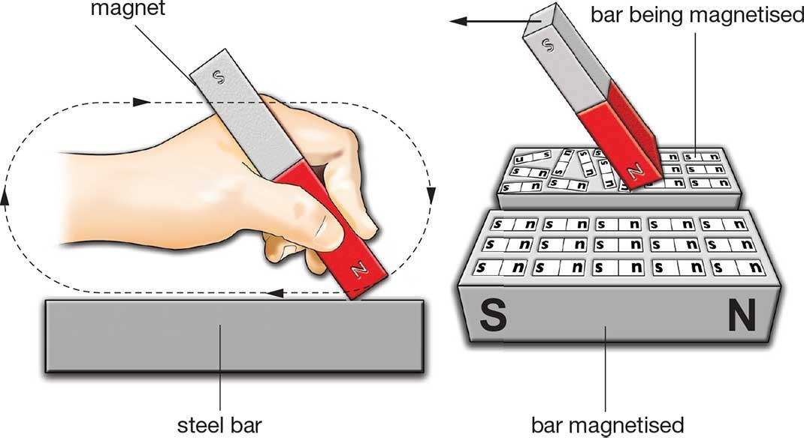

### Hammering Method

Hammering a ferromagnetic material while aligned with Earth's magnetic field helps domains align and induces magnetism. The domains will begin to line up in the direction of the applied magnetic field and hence the metal bar becomes magnetized. This method is mainly used for magnetization of steel.

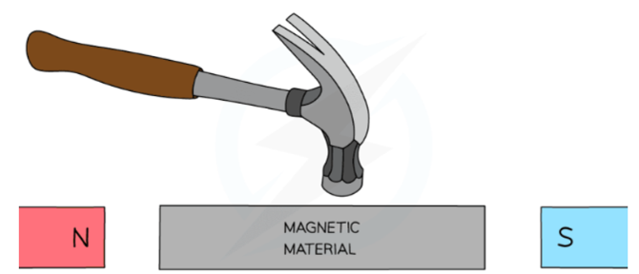

### Heating Method

Heating and then cooling a material in the presence of a magnetic field causes domain alignment, producing magnetism. This phenomenon is referred to as the 'magnetic Seebeck effect' or 'thermo-magnetism'.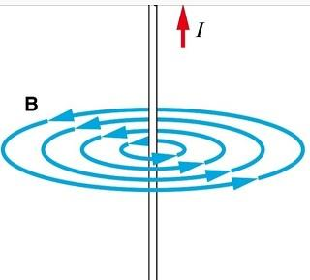

### Solenoid

A solenoid is a coil of wire with current passing through it, producing a field similar to a bar magnet. A solenoid is a cylindrical coil. The magnetic field of the conducting resembles wire with the field of a bar magnet. When we wrap a (say a copper wire) around a metal with insulation the domains of the metal get aligned. In this process when a current flows through the wire it generates a magnetic field which behaves as an external field to the domains of metal placed inside, which aligns the domains.

The magnetic field of a solenoid can mathematically be given as:

$B=μ_{o}n I$, where

**B = strength of magnetic field, having unit tesla (T)**, which is also equal to newton per ampere per meter **(N A-1 m-1)**

**μ = is the permeability of the material**, and

**l = current flowing through the solenoid**.

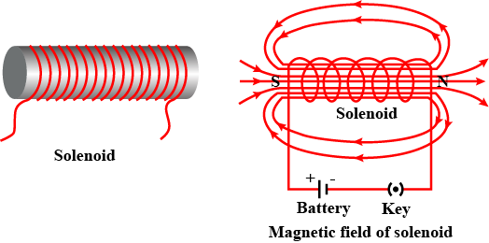

### 8.3.1 Temporary and Permanent Magnets

The solenoid as stated earlier behaves like a magnet as long as a current flows through it, just after removal of current it loses its magnetic field, hence it is a temporary magnet. It is also called an electromagnet.

Electromagnet is a type of magnet in which the magnetic field is produced due to an electric current. Examples of temporary magnetics include iron nails, screws, metal bolts, kitchen utensils etc.

Temporary magnets lose magnetism quickly after the external field is removed, while permanent magnets retain magnetism for a long period.

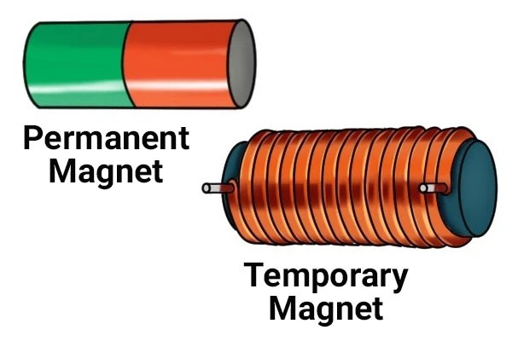

| **Differences Between Permanent Magnets and Electromagnets** | |
| --- | --- |
| **Permanent Magnet** | **Electromagnet** |
| Made of hard magnetic materials | Made by current through coils |
| Always magnetic | Magnetic only when current flows |
| Fixed strength | Variable strength |
| Used in compasses, door locks | Used in cranes, motors, relays |
| Magnets' poles can not be altered | Magnets' poles can be changed |

### 8.3.2 Uses of Permanent Magnets and Electromagnets

Permanent magnets are used in compasses, magnetic locks, and speakers. Electromagnets are used in cranes, electric bells, motors, and relays.

Permanent magnets are used in induction cookers, MRI machines, particle accelerators, transformers etc. and in automotive, aerospace, medical, semiconductor and energy industries.

Electromagnets have a wide range of daily life applications like in electromechanical and electronics devices. They are used in electric fans, electric motors and door bells. In medical fields, electromagnets are used in MRI scans.

### 8.3.2. Applications of Magnets

**Magnetic Recording**: Used in tapes and hard drives where data is stored by aligning magnetic particles.

For writing the data a magnetic tape head is moved onto the tape which is in motion the magnetic field of the tape head aligns the pattern of magnetic domains according to the applied current flowing through the tape head.

**Speakers**: Electromagnets interact with permanent magnets to move diaphragms and produce sound.

To produce sound the speaker needs to create some vibrations in the air. This can be done with the help of two magnets, one permanent magnet of strong magnetization and the other is electromagnet.The permanent magnet is fixed in the centre of the cone, which is a conical structure made up of some flexible material to move to vibrations.

The commonly used material as permanent magnet in speakers is neodymium.

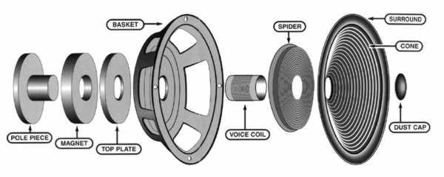

**Door Locks**: Electromagnets lock or unlock doors by magnetic force.

They have an electromagnet fixed at the door frame and a metal plate fixed with the door, in such a way that when the door is closed the metal plate connects with the electromagnet.

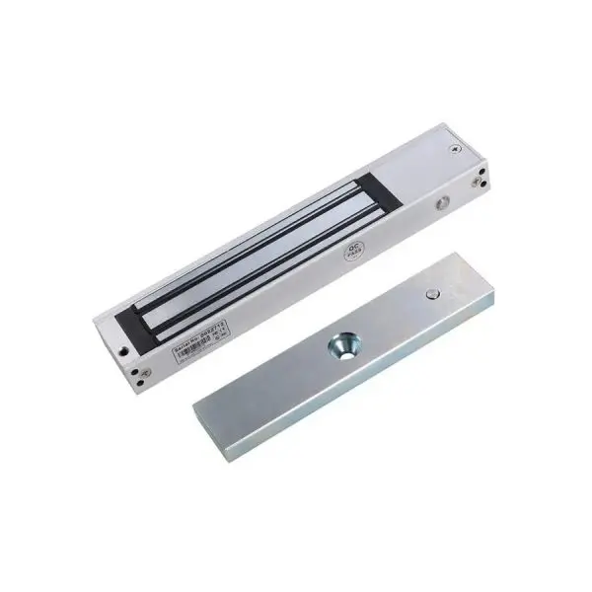

## 8.4 Types of Magnetic Materials

On the basis of the behavior of materials to the applied external magnetic field, they are classified into three types, i.e. diamagnetic, paramagnetic and ferromagnetic materials.

* **Diamagnetic**: They are slightly repelled by a magnetic field and do not retain the magnetic properties when the external field is removed. Their magnetic field intensity is very small and opposite to the external magnetic field. Examples of diamagnetic materials are copper, zinc, bismuth, silver, gold, marble, water, glass and wood etc.
* **Paramagnetic**: On the application of external magnetic fields they align themselves in the direction of the applied field and hence the material is feebly magnetized. They experience weak attraction to magnets. Their magnetic field intensity is small and along the direction of the external magnetic field. Examples of paramagnetic materials are tungsten, aluminum, lithium and sodium etc.
* **Ferromagnetic**: When placed in an external field these materials are strongly magnetized in a direction parallel to the applied field and hence they are strongly attracted to a magnet. They retain their magnetization even after removal of applied magnetic field. Examples of these materials include iron, cobalt, nickel and some metallic alloys.

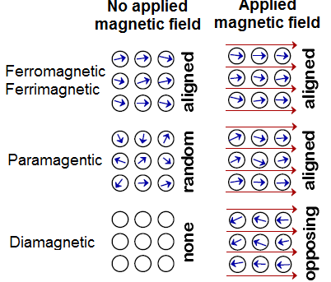

### 8.4.1 Difference Between Magnetic and Non-Magnetic Materials

| **Difference Between Magnetic and Non-Magnetic Materials** | |
| --- | --- |
| **Magnetic Materials** | **Non-Magnetic Materials** |
| Respond strongly to fields | Do not respond to fields |
| Magnetic materials can attract and repel other magnetic materials | Non-magnetic cannot attract or repel any magnetic material |
| The atomic states of a magnetic material are aligned | The atomic states of a nonmagnetic material are in random |
| Materials which are attracted to a magnet are known as magnetic materials | Materials which are not attracted to a magnet are known as non-magnetic materials |
| Examples: iron, nickel | Examples: wood, plastic |

## 8.5 Earth's Magnetic Field

The Earth behaves like a bar magnet with magnetic poles near its geographical poles. This field shields the Earth from solar winds and cosmic rays and guides compasses.

Earth's field is also known as a geomagnetic field. The presence of a magnetic field acts like a protective shield around the Earth, which saves life on Earth from harmful cosmic rays coming from outer space and the charge particles and radiations coming from the Sun. The Earth's magnetic field extends millions of kilometers into space but has very small magnetic field strength.

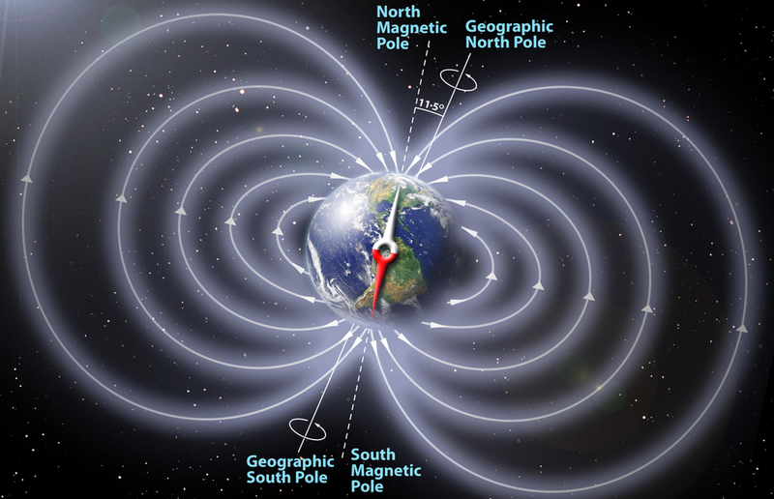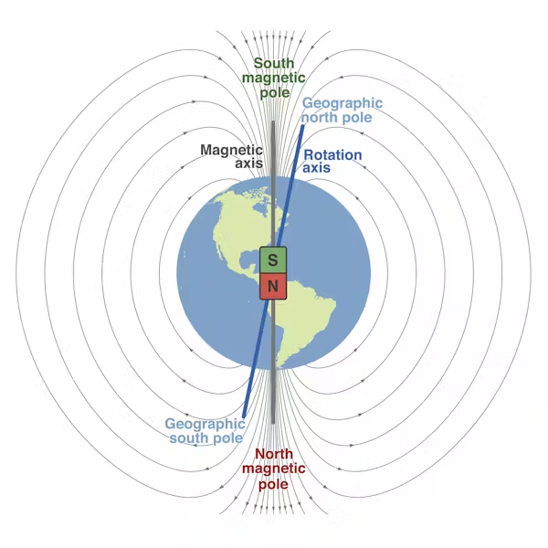

### 8.5.1 Geographical and Magnetic Poles

Geographical poles are based on Earth’s axis of rotation, while magnetic poles are where magnetic field lines converge. The magnetic poles shift slowly over time. Our Earth spins about its geographical axis (The line joining the geographical poles of the Earth). The magnetic poles of Earth are inclined at an angle of 11.3° to the geographical poles.

### 8.5.2 Bio-Magnetism

Bio-magnetism refers to magnetic fields produced by living organisms due to ionic currents. It is significant in medicine, for example in magnetoencephalography (MEG) and magnetocardiography.

Magnetism also plays a main role in the behavior of many species living on the planet. Like human's hearts and brains produce some magnetic fields for their working, without these fields these organs are of no use. These magnetic fields produced by the brain and heart are also used for diagnostic techniques.

